**VARUN KUMAR**

**2K19/IT/140**

**OOP LAB – 11**

**1)**

**#include <iostream>**

**using namespace std;**

**class Animal {**

**public:**

**int A;**

**Animal()**

**{**

**cout<<"Animal class constructor called !!!\n\n" ;**

**}**

**~Animal(){**

**cout<<"Animal class destructor called !!!\n\n" ;**

**}**

**};**

**class Herbivores : virtual public Animal {**

**public :**

**int H;**

**Herbivores(){**

**cout<<"Herbivores class constructor called !!!\n\n" ;**

**}**

**~Herbivores(){**

**cout<<"Herbivores class destructor called !!!\n\n" ;**

**}**

**};**

**class Carnivores : virtual public Animal {**

**public:**

**int C;**

**Carnivores(){**

**cout<<"Carnivores class constructor called !!!\n\n" ;**

**}**

**~Carnivores(){**

**cout<<"Carnivores class destructor called !!!\n\n" ;**

**}**

**};**

**class Omnivores : public Herbivores, public Carnivores {**

**public:**

**int O;**

**Omnivores(){**

**cout<<"Omnivores class constructor called !!!\n\n" ;**

**}**

**~Omnivores(){**

**cout<<"Omnivores class destructor called !!!\n\n" ;**

**}**

**};**

**int main()**

**{**

**Omnivores obj;**

**return 0;**

**}**

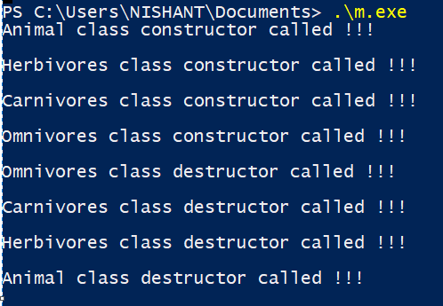

**2)**

#include <iostream>

#include<string>

using namespace std;

class admission

{

public:

string name;

virtual void procedure_details()=0;

virtual void doc_req()=0;

void virtual contact()=0;

};

class college_admission:public admission

{

public:

college_admission()

{

name= "Delhi Technological University, Delhi\n";

}

void procedure_details()

{

cout<<"\t\t\t\tSteps to follow\n";

cout<<"Step 1:\nFee Payment\n\n";

cout<<"Step 2:\nRegistration\n\n";

cout<<"Step 3:\nLogin to JAC Delhi Account\n\n";

cout<<"Step 4:\nChoice Filling\n\n";

cout<<"Step 5:\nChoice Locking and Printing of Locked Choices\n\n";

cout<<"Step 6:\nReporting at Allotted Institute\n\n\n";

}

void doc_req()

{

cout<<"\t\t\t\tList of Documents Requried\n";

cout<<"1.Applicable fee payment receipt of Rs. 10,000\n";

cout<<"2.Three passport size photographse\n";

cout<<"3.Self-attested copies of Admit Card and Score Card of JEE Main 2020\n";

cout<<"4.Original marksheet of the qualifying examination i.e. Class 12th\n";

cout<<"5.Original Date of Birth certificate as indicated in High School examination i.e. Class 10th\n";

cout<<"6.Photo Identity proof of both the parents\n";

cout<<"7.Photocopy of Residential Address Proof\n\n\n";

}

void contact()

{

cout<<"For any query kindly contact:\n";

cout<<"Fax: +91-11-27871023\nPhone: +91-11-27871018\n\n\n";

}

};

class school_admission:public admission

{

public:

school_admission()

{

name="Delhi Public School Surat\n";

}

void procedure_details()

{

cout<<"\t\t\t\tSteps to follow\n";

cout<<"Step 1:\nCOMPLETE ONLINE REGISTRATIN FORM\nwww.dpssurat.net\n\n";

cout<<"Step 2:\nKNOW EACH OTHER SESSION\nInteraction with school committee\n\n";

cout<<"Step 3:\nADMISSION STATUS\nProvisional Selection Status\n\n";

cout<<"Step 4:\nCOMPLETE ADMISSION FORMALITIES\nAs per the schdule\n\n";

}

void doc_req()

{

cout<<"\t\t\t\tList of Documents Requried\n";

cout<<"1.Completed registration form\n";

cout<<"2.Copy of birth certificate\n";

cout<<"3.Transfer certificate\n";

cout<<"4.Mark sheet of the last exam\n";

cout<<"5.Passport size photograph\n";

cout<<"6.Photo Identity proof of both the parents\n";

cout<<"7.Photocopy of Residential Address Proof\n\n\n";

}

void contact()

{

cout<<"For any query kindly contact:\n";

cout<<"Email:info@dpssurat.net\n7600057383 / 91-261-2654014 / 265402\n\n\n";

}

};

int main() {

college_admission *c1=new college_admission;

school_admission *s1=new school_admission;

int x;

do

{

cout<<"1.School Admission\t\t2.College Admission\t\t3.Exit\n";

cout<<"\t\t\t\tEnter your choice:";

cin >>x;

switch(x)

{

case 1:

{

int a;

cout<<"\n\n\t\t\t\t"<<s1->name<<endl<<endl;;

do

{

cout<<"1.Procedure Details\t2.Documents Requried\t3.Contact\t4.Exit\n";

cout<<"\t\t\t\tEnter your choice:";

cin >>a;

switch(a)

{

case 1:

{

s1->procedure_details();

break;

}

case 2:

{

s1->doc_req();

break;

}

case 3:

{

s1->contact();

break;

}

case 4:

{

cout<<"Thank You for visiting "<<s1->name<<endl;

break;

}

default:

{

cout<<"Please, choose correct option!\n";

}

}

}

while(a!=4);

}

case 2:

{

int a;

cout<<"\n\n\t\t\t\t"<<c1->name<<endl<<endl;

do

{

cout<<"1.Procedure Details\t2.Documents Requried\t3.Contact\t4.Exit\n";

cout<<"\t\t\t\tEnter your choice:";

cin >>a;

switch(a)

{

case 1:

{

c1->procedure_details();

break;

}

case 2:

{

c1->doc_req();

break;

}

case 3:

{

c1->contact();

break;

}

case 4:

{

cout<<"Thank You for visiting "<<c1->name<<endl;

break;

}

default:

{

cout<<"Please, choose correct option!\n";

}

}

}

while(a!=4);

}

case 3:

{

cout<<"Thanks for visiting\n";

break;

}

default:

{

cout<<"\n";

}

}

}

while(x!=3);

return 0;

}

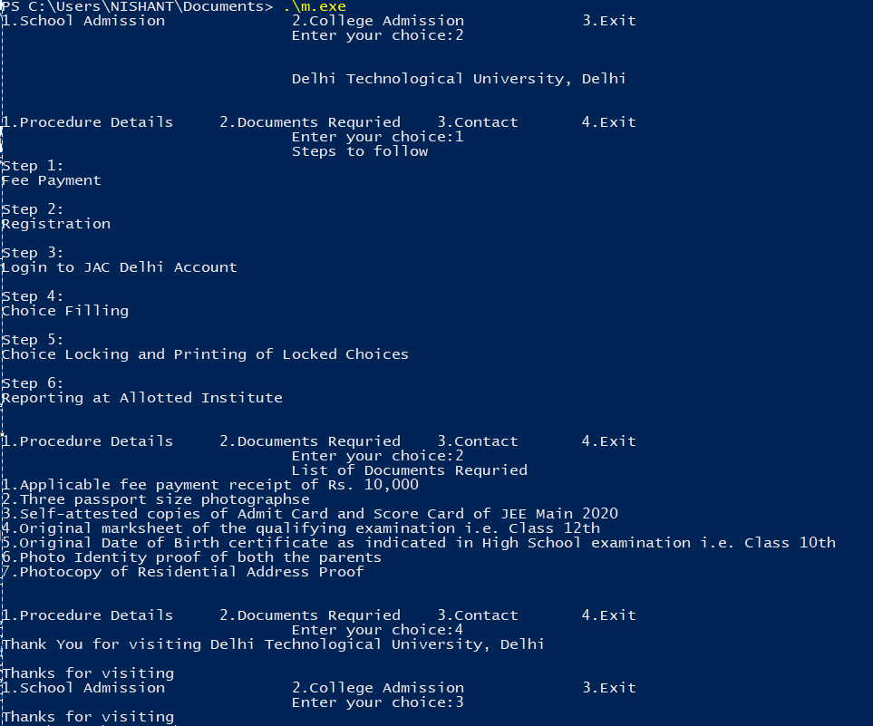

**3)**

**#include<iostream>**

**using namespace std;**

**class A**

**{**

**public:**

**A()**

**{**

**cout<<"Constructor of A\n";**

**}**

**virtual ~A()**

**{**

**cout<<"Destructor of A\n";**

**}**

**};**

**class B:public A**

**{**

**public:**

**B()**

**{**

**cout<<"Constructor of B\n";**

**}**

**~B()**

**{**

**cout<<"Destructor of B\n";**

**}**

**};**

**class C**

**{**

**public:**

**C()**

**{**

**cout<<"Constructor of C\n";**

**}**

**~C()**

**{**

**cout<<"Destructor of C\n";**

**}**

**};**

**class D:public C**

**{**

**public:**

**D()**

**{**

**cout<<"Constructor of D\n";**

**}**

**~D()**

**{**

**cout<<"Destructor of D\n";**

**}**

**};**

**int main()**

**{**

**cout<<"\t\t\tWITH VIRTUAL DESTRUCTOR\n";**

**A *ob1=new B;**

**cout<<endl;**

**delete ob1;**

**cout<<endl;**

**cout<<"\t\t\tWITHOUT VIRTUAL DESTRUCTOR\n";**

**C* ob2=new D;**

**cout<<endl;**

**delete ob2;**

**return 0;**

**}**

